Modbus Bridge Setup & DSP Configuration Guide
Purpose. Configure a Modbus bridge and its connected devices end to end: wire and program the sensor, program the bridge, add the bridge in Digital Solutions Platform (DSP), then define and verify the reported measurements.
High-level sequence: Connect the Modbus sensor to the bridge → configure the sensor → configure the bridge → add the bridge in DSP → map and verify measurements.

1. Assumptions
- The user is familiar with basic Modbus wiring and setup methodology.
- A Windows PC is available that can install executable software. Polygon-compliant PCs may restrict .EXE installation.

2. Hardware required
- Synetica Modbus bridge
- USB-A to USB Micro cable
- Windows PC
- At least one supported Modbus device
- Power and communication wiring/cables
- 15–24 VDC power supply
- Vaisala DPT146
- Vaisala HMD65
- ATI F12 system
- Micronics U1000MKII flowmeter (wall or pipe mount)
- Continental Control Systems / Socomec WattNode WND-M1-MB

3. Software required
- Polygon Device Configurator — v0.1.0 Beta 13 in the source setup guide.

4. Wiring
Wire power to the Modbus bridge, then wire RS-485 between the bridge and every attached sensor. Confirm polarity, common/ground, and termination according to the device manuals before powering the system.

5. Sensor setup
Model-specific sensor programming must match the bridge serial settings and slave IDs. The source setup guide provides detailed switch settings for the HMD65; the other listed models require their corresponding device configuration.

5.1 Vaisala HMD65
Set the internal DIP switches as follows:
Setting | Value
Modbus address | 1 — DIP switch bank 1, switch 8 ON
Bit rate | 9600 — DIP switch bank 2, switch 6 ON
Parity | None — DIP switch bank 2, switch 8 OFF
Mode | Modbus — DIP switch bank 3, switch 8 OFF
Analog output for humidity | DIP switch bank 3, switch 1 ON
RS-485 termination | OFF

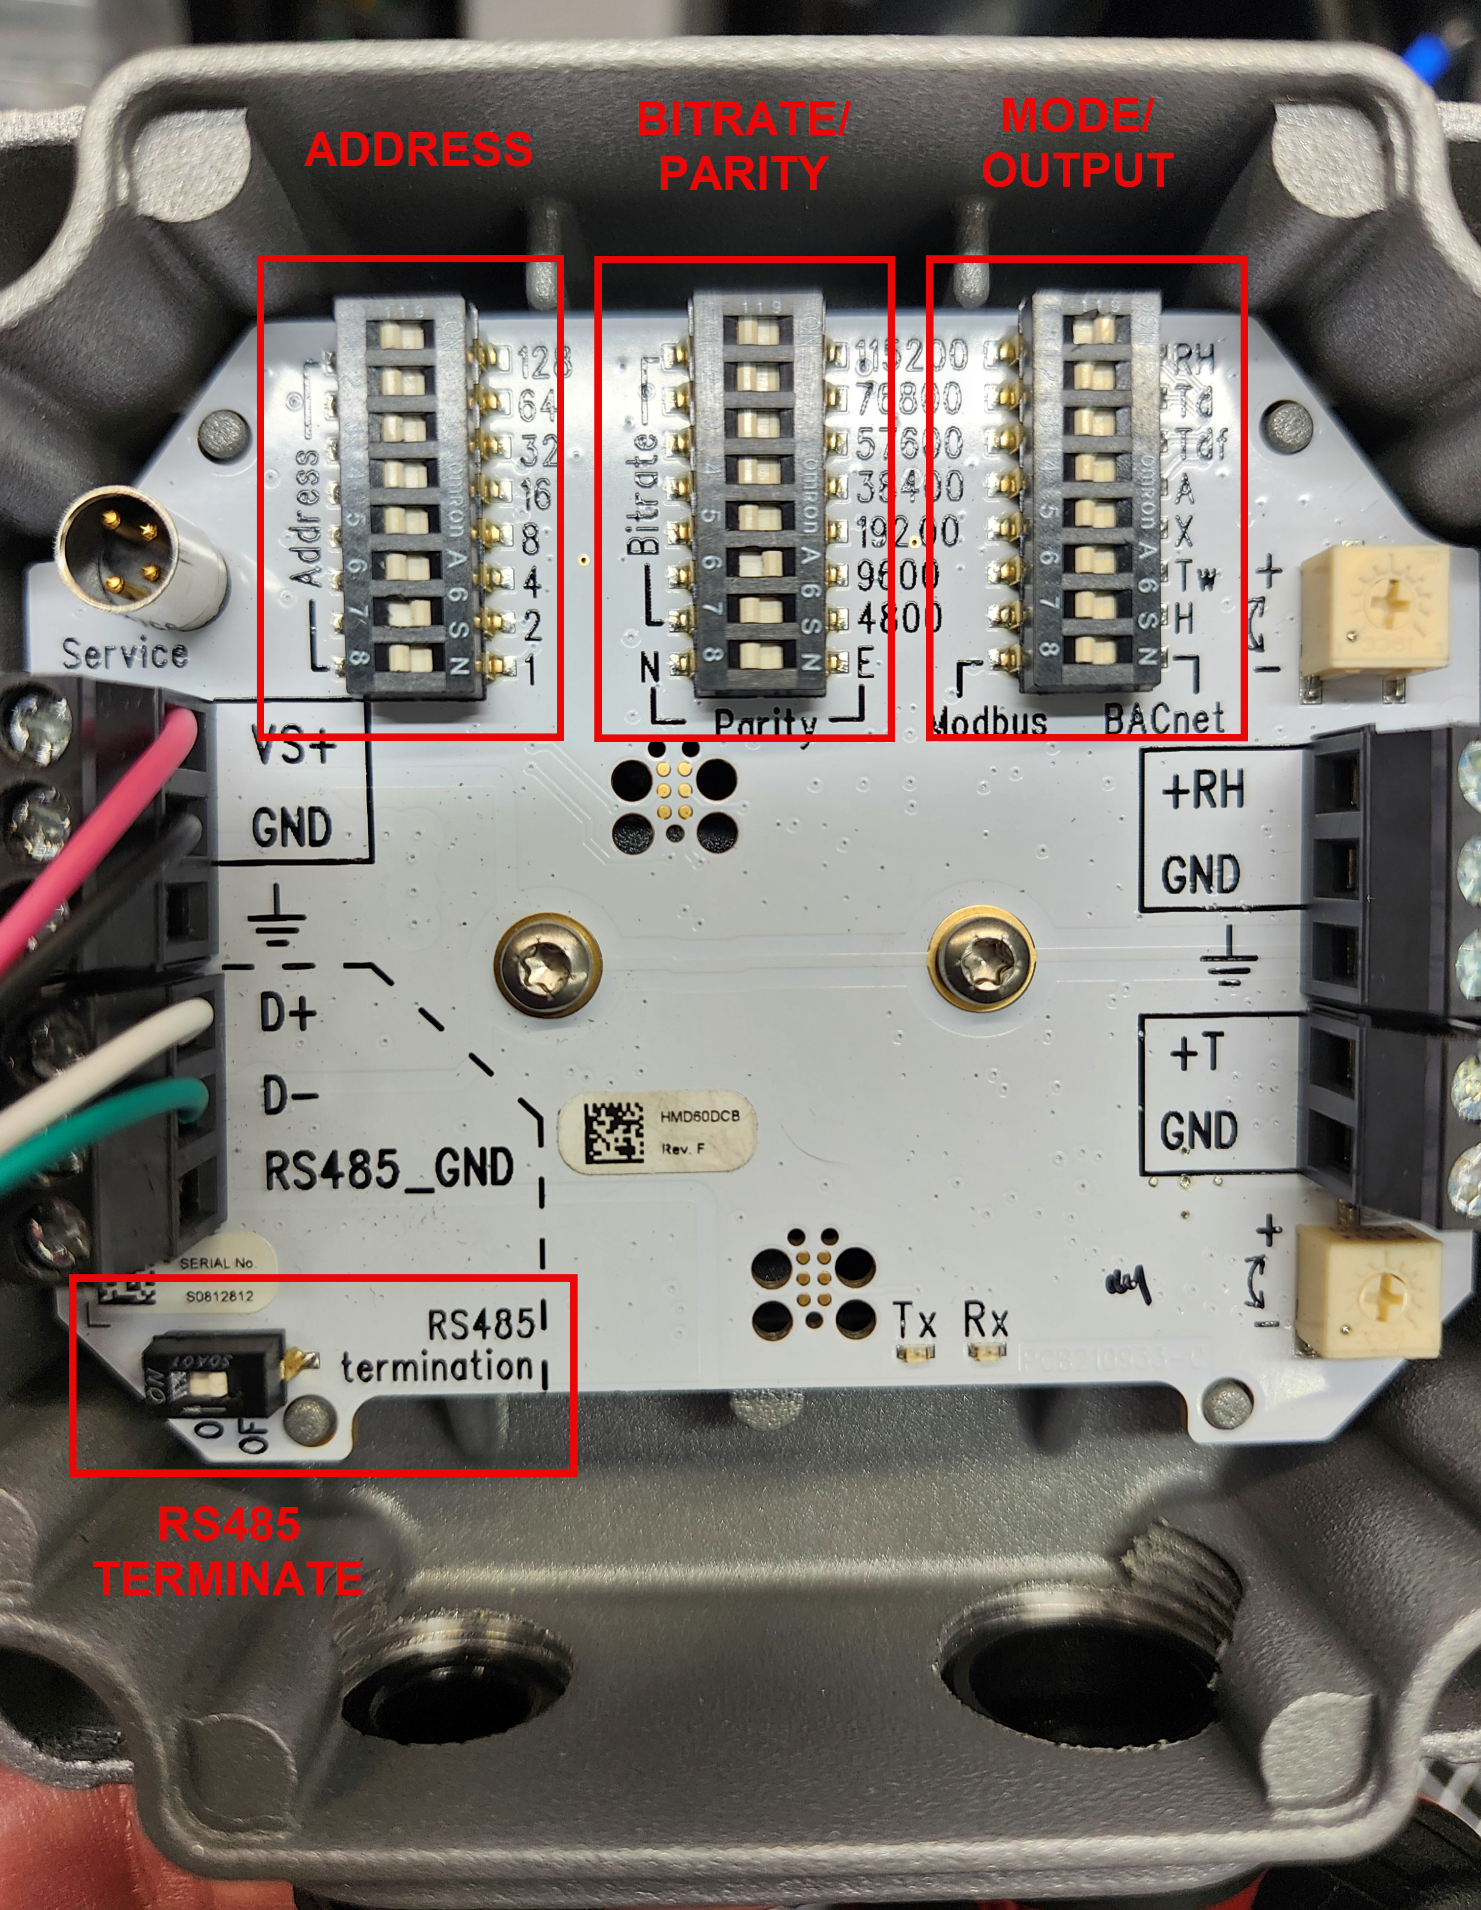
HMD65 switch-bank example from the original setup guide.

6. Bridge setup in Polygon Device Configurator
1. Power up the Modbus bridge and all connected sensors.
2. Connect the Modbus bridge to the PC over USB.
3. Open Polygon Device Configurator. The tool automatically searches for attached devices; detection may take 30–60 seconds.
4. After the bridge is detected, copy its LoRaWAN EUI and save it for the later Loriot/DSP setup.
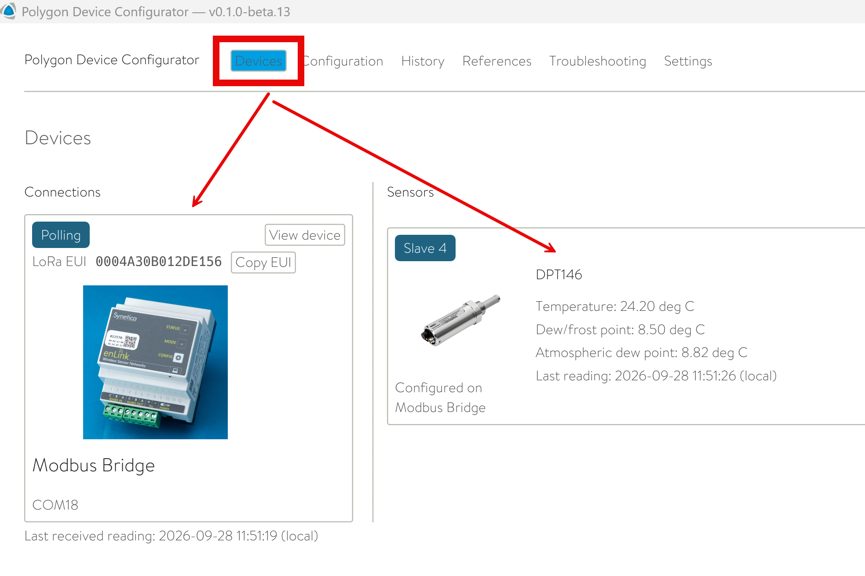
Detected bridge and downstream sensor in Polygon Device Configurator.
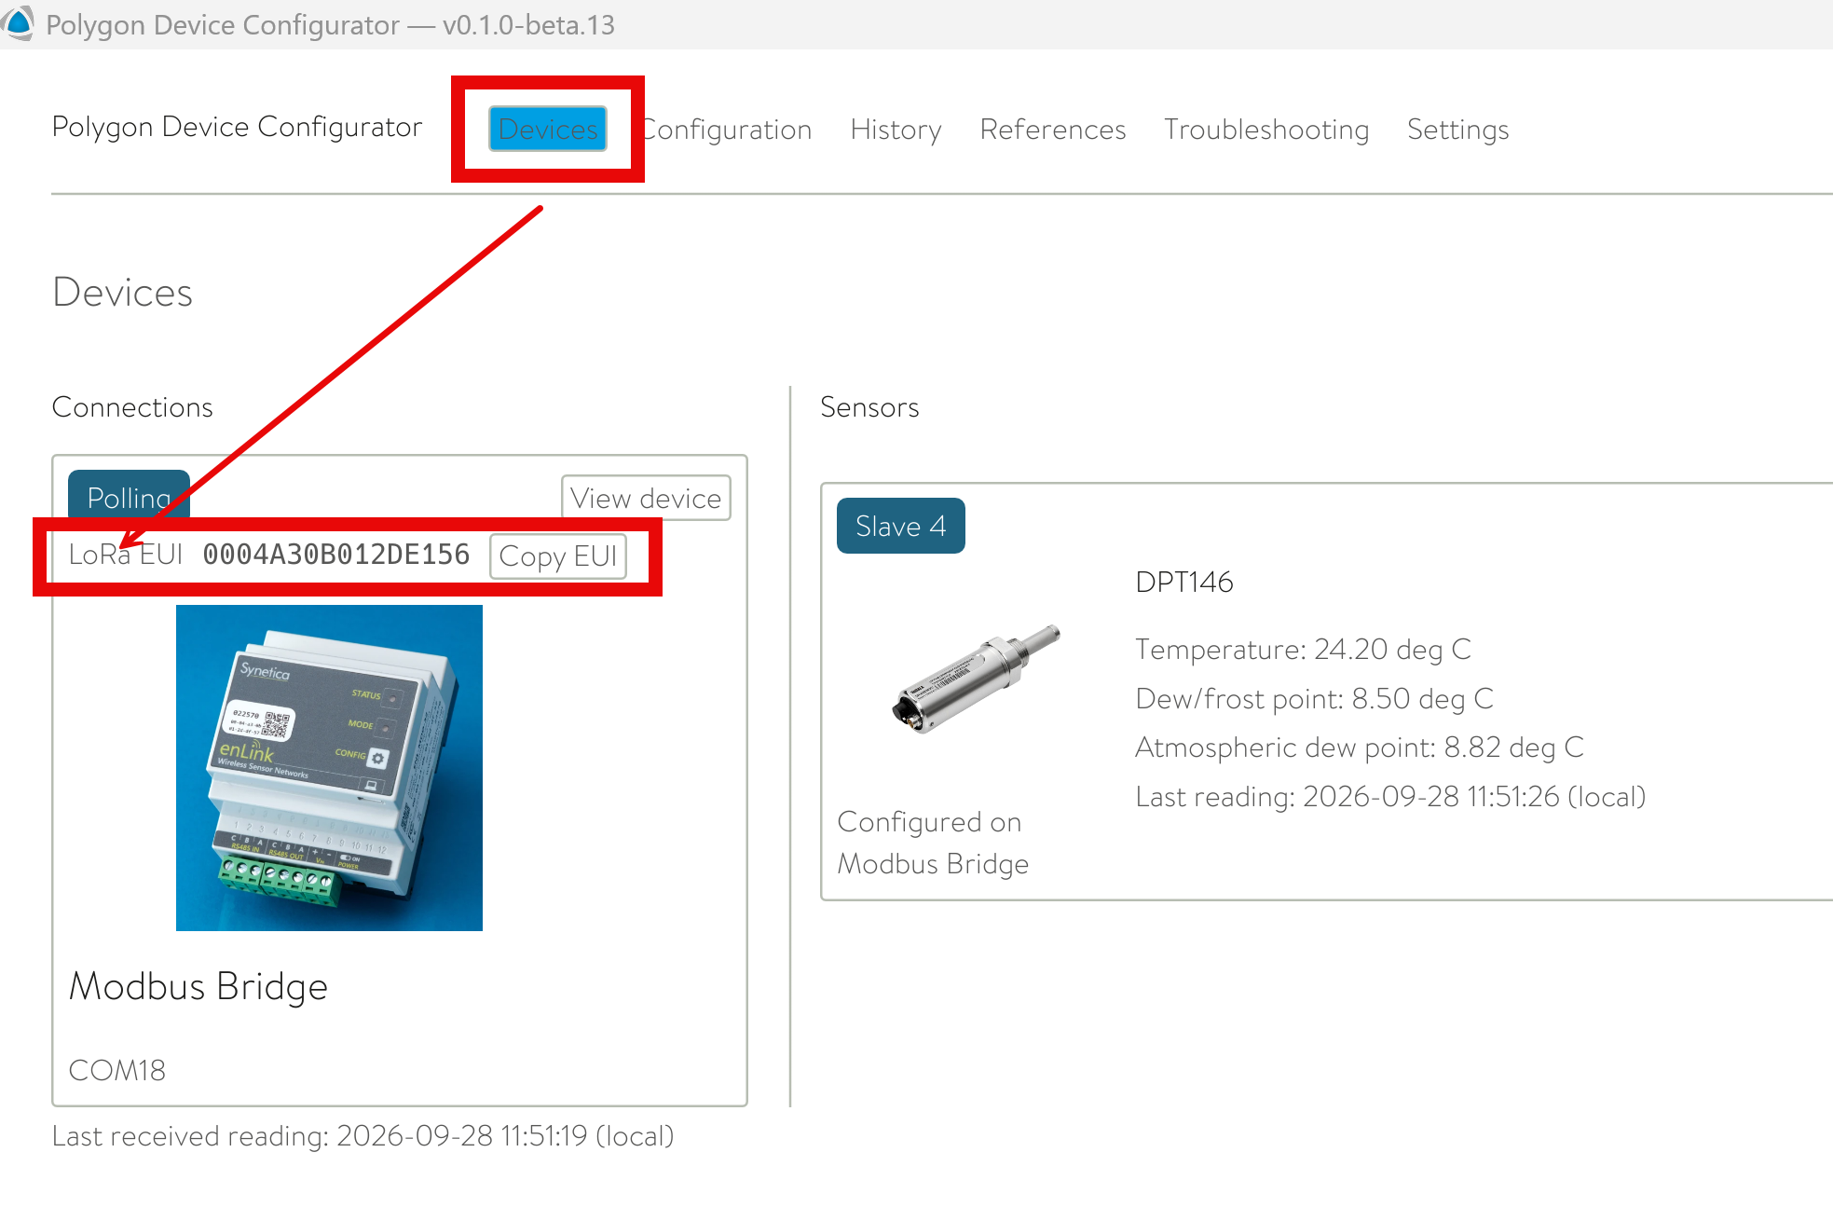
Copy the bridge LoRaWAN EUI for later setup.

6.1 Program the bridge
1. Open the Configuration tab.
2. Configure the RS-485 line settings to match the attached sensors: 9600 baud, 8 data bits, no parity, 1 stop bit.
3. Click “Apply line settings”.
4. Choose the point table / downstream device profile.
5. Choose the slave or child ID matching the sensor configuration. ID 1 is typical for a single connected device.
6. Click “Program Modbus Bridge”.
7. Return to Devices and confirm all attached devices are updating.
8. Use the History tab to inspect live/historical values and verify downstream operation.
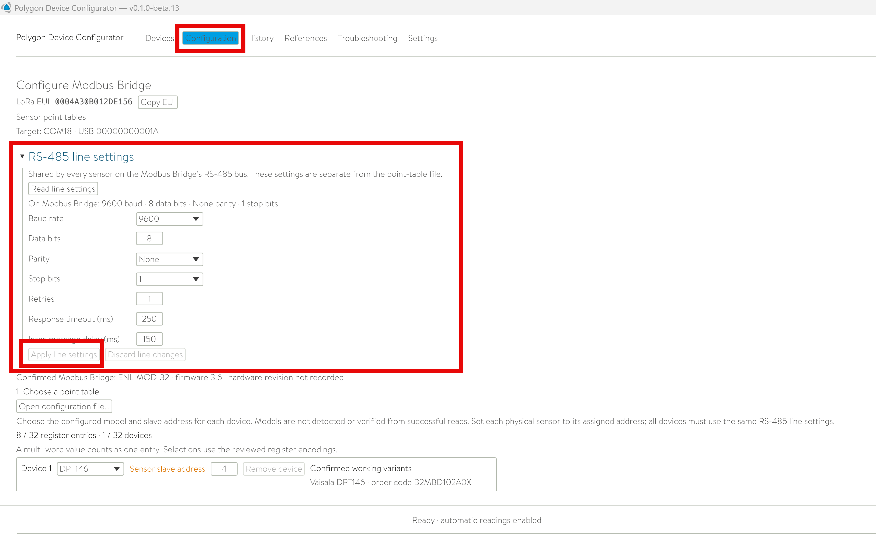
RS-485 line settings in the bridge configuration view.
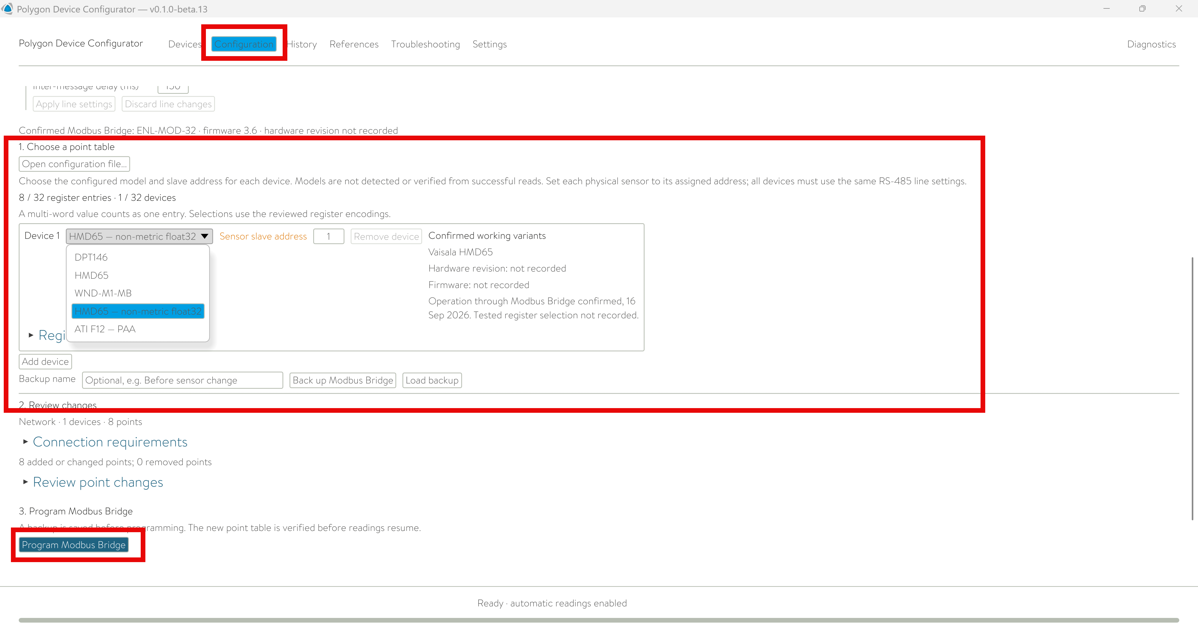
Select the downstream profile and slave ID, then program the bridge.
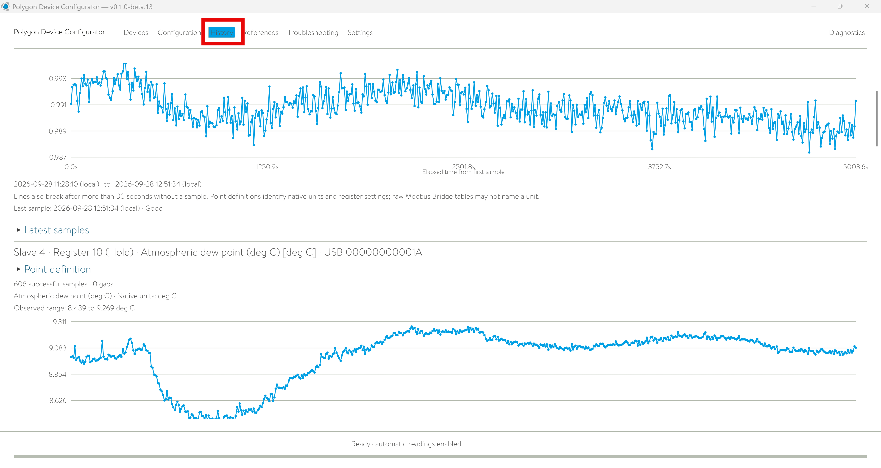
Use History to confirm that downstream measurements are updating.

7. Digital Solutions Platform setup

7.1 Add the bridge to the project
1. Navigate to the project where the Modbus sensor should appear.
2. Add a device.
3. Choose Physical device.
4. Choose Modbus Bridge SL10.
5. Enter the LoRaWAN EUI copied earlier, with no spaces or special characters.
6. Click Add to complete device creation.
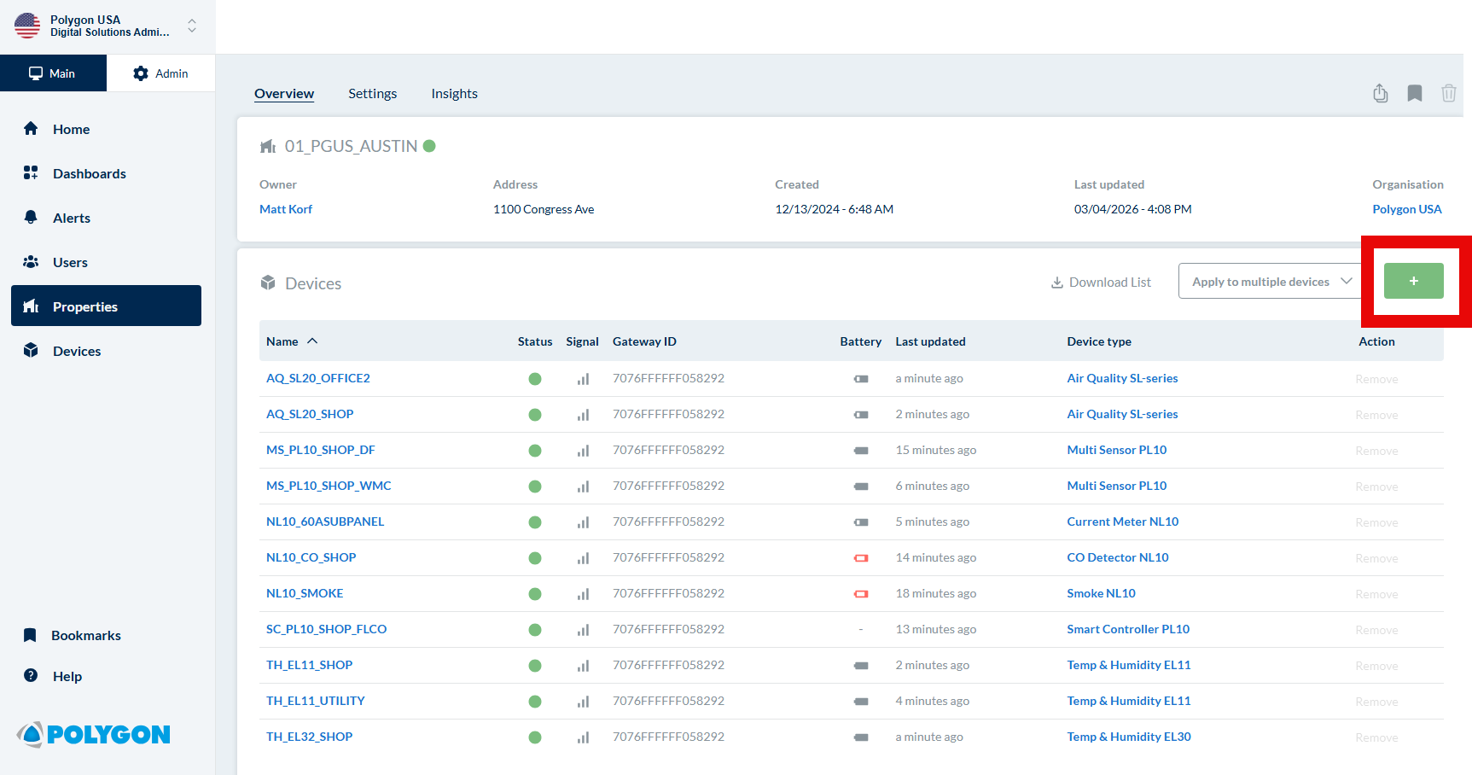
Add a device from the DSP project device list.
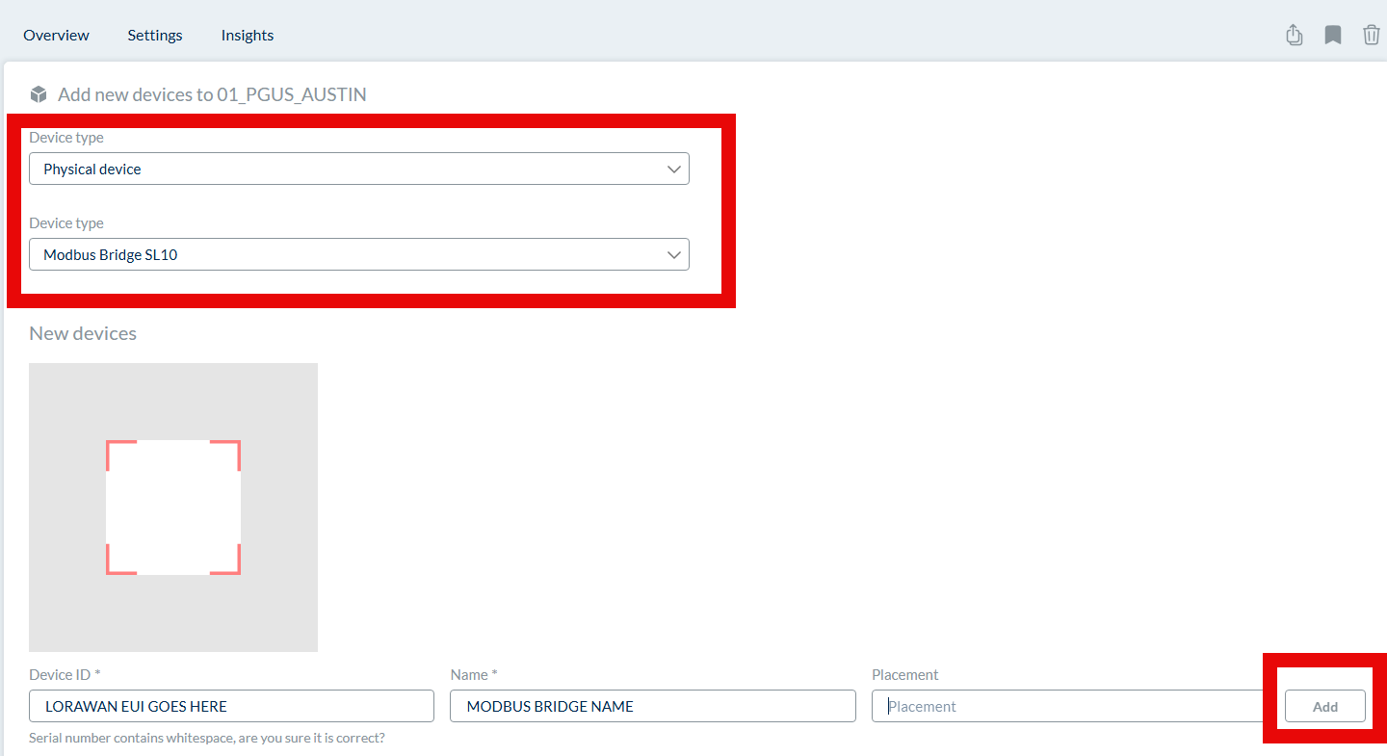
Choose Physical device → Modbus Bridge SL10 and enter the bridge EUI.

7.2 Configure DSP measurements
Open the bridge device, go to Settings, then open the Measurements section.
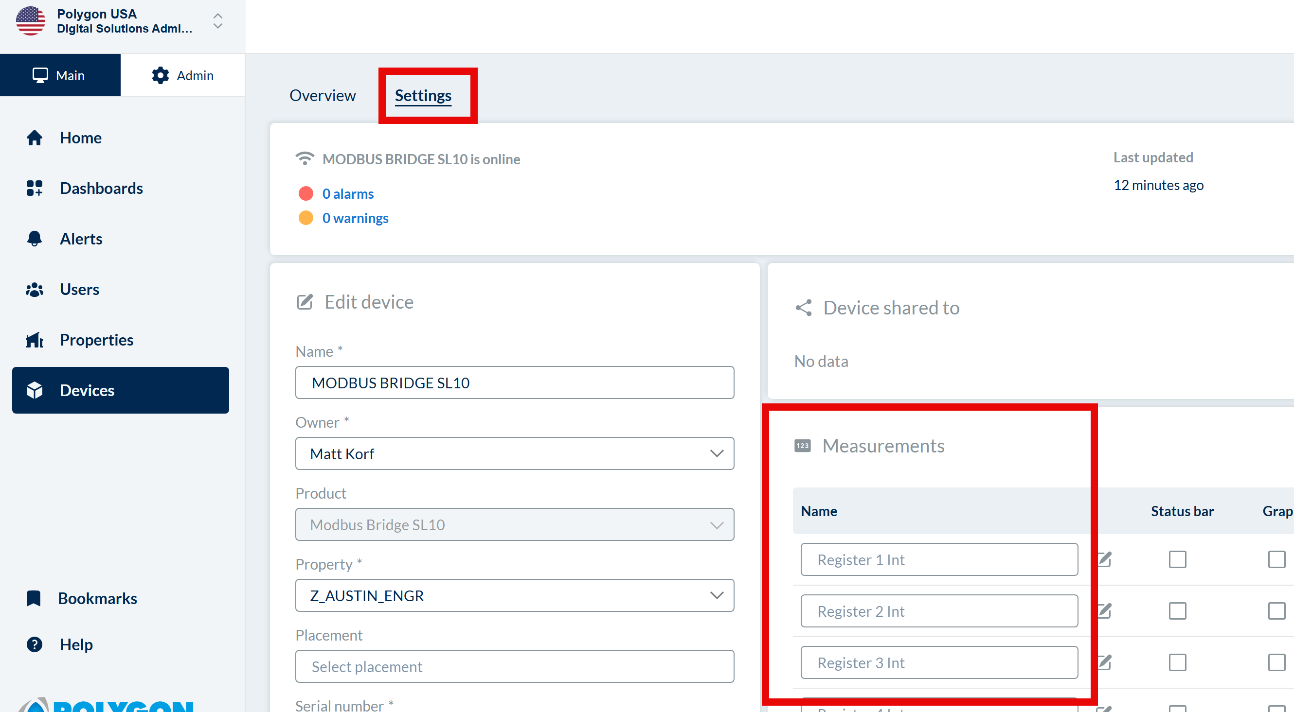
The device Settings page includes the numbered measurement fields used by the bridge.
Int vs. Cum measurements. DSP exposes two sets of register labels. The “Int” set is the normal/default use case. The “Cum” set reads the same registers but is intended for a bridge configuration that delays data sends and treats the register as cumulative. The bridge defaults use the first 32 “Int” entries, so the cumulative fields can normally be left alone unless that mode is deliberately enabled.
Editing a measurement. Click the edit icon for a numbered measurement. The name field controls the label. Output type can be Numeric or Lookup table. Numeric fields can be assigned a built-in unit, and custom units allow free-text unit entry. Lookup tables map incoming values to readable labels and are most useful for true enumerations or defined encoded states.
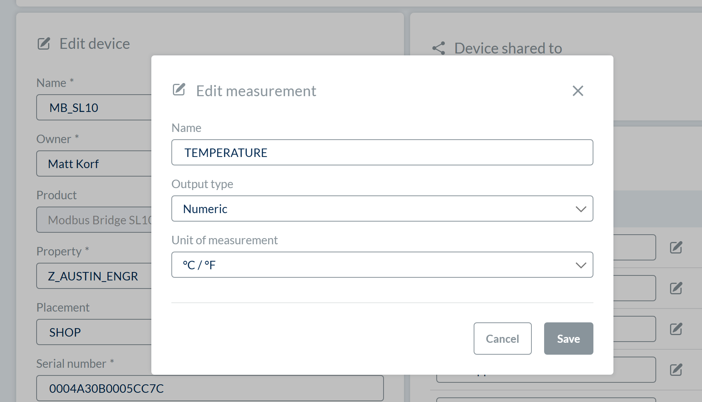
DSP measurement editor: name, output type, and unit of measurement.
Naming tip for multi-slave bridges: Include the downstream device and slave ID in the measurement name, for example: “HMD65 - 2 - Temperature”.

7.3 Match bridge entries to DSP measurements
Use the References section in Polygon Device Configurator to see the point table for the selected downstream profile, including register names, data types, and units. Match the bridge entry number, not the instrument register number. A two-register floating-point value still occupies one bridge entry and one DSP measurement. If a decoder shows zero-based point indices, point 0 corresponds to bridge entry 1.
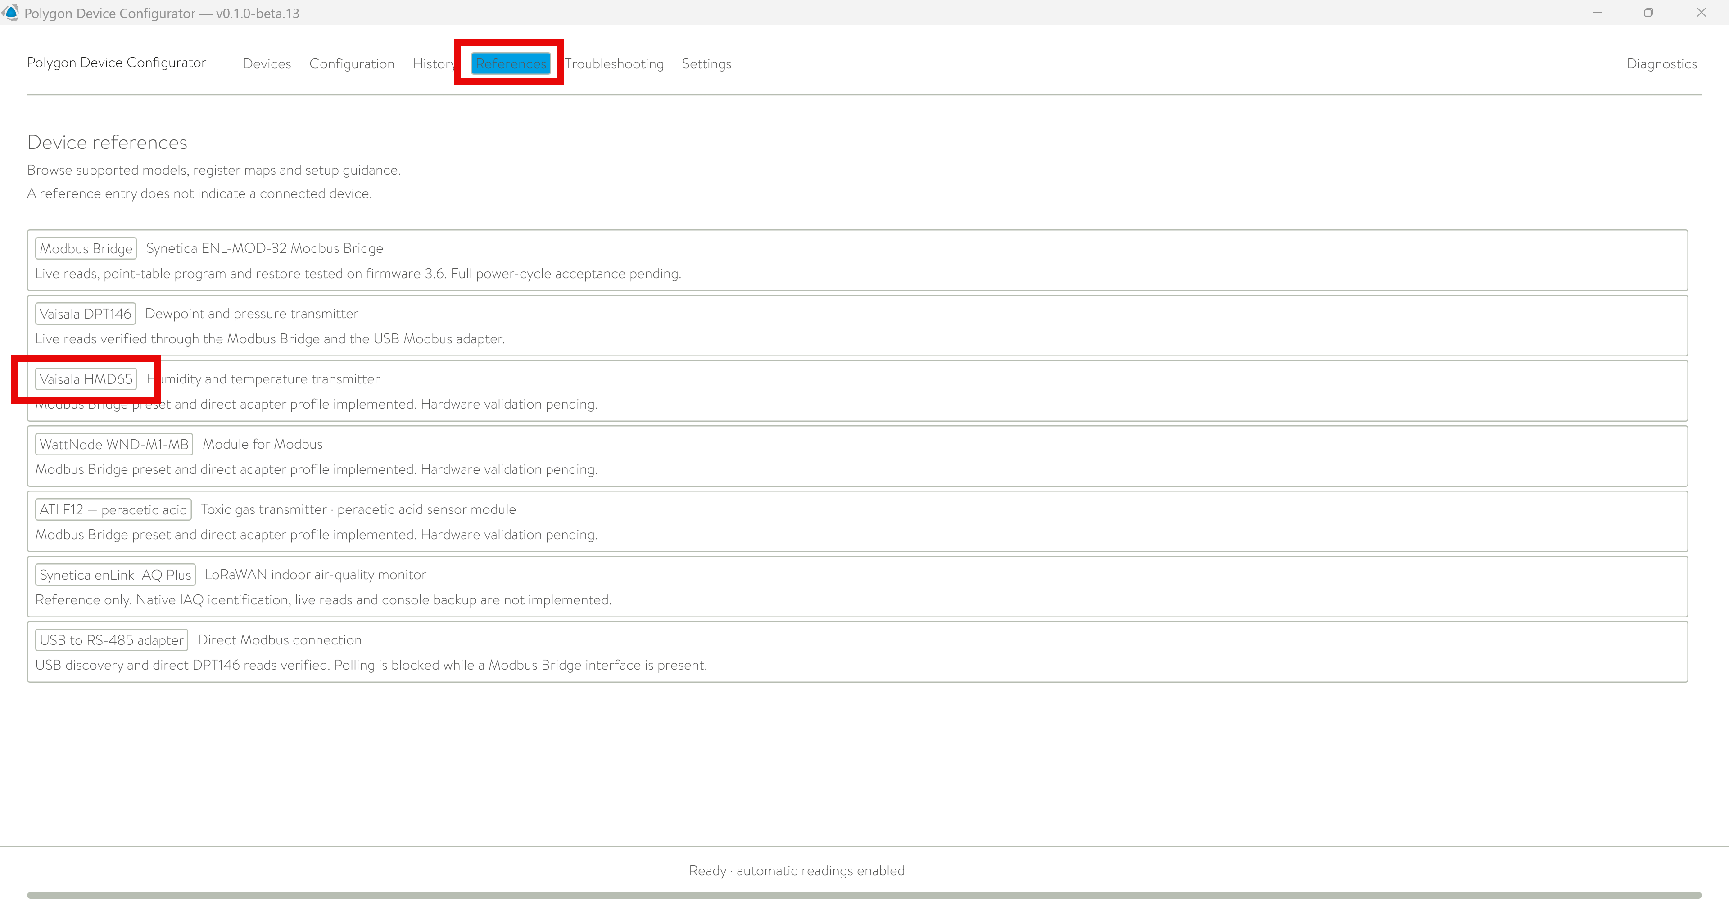
Open References in Polygon Device Configurator to inspect the installed device profile.
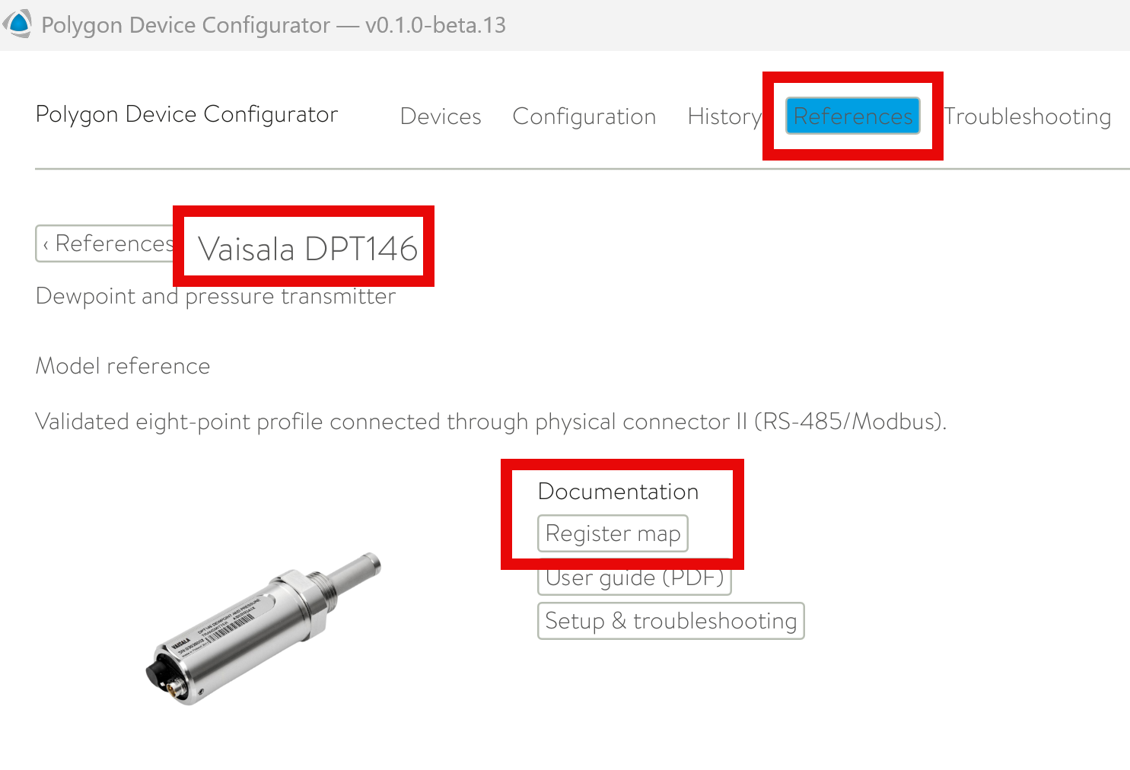
Select the downstream device reference and open its register map.
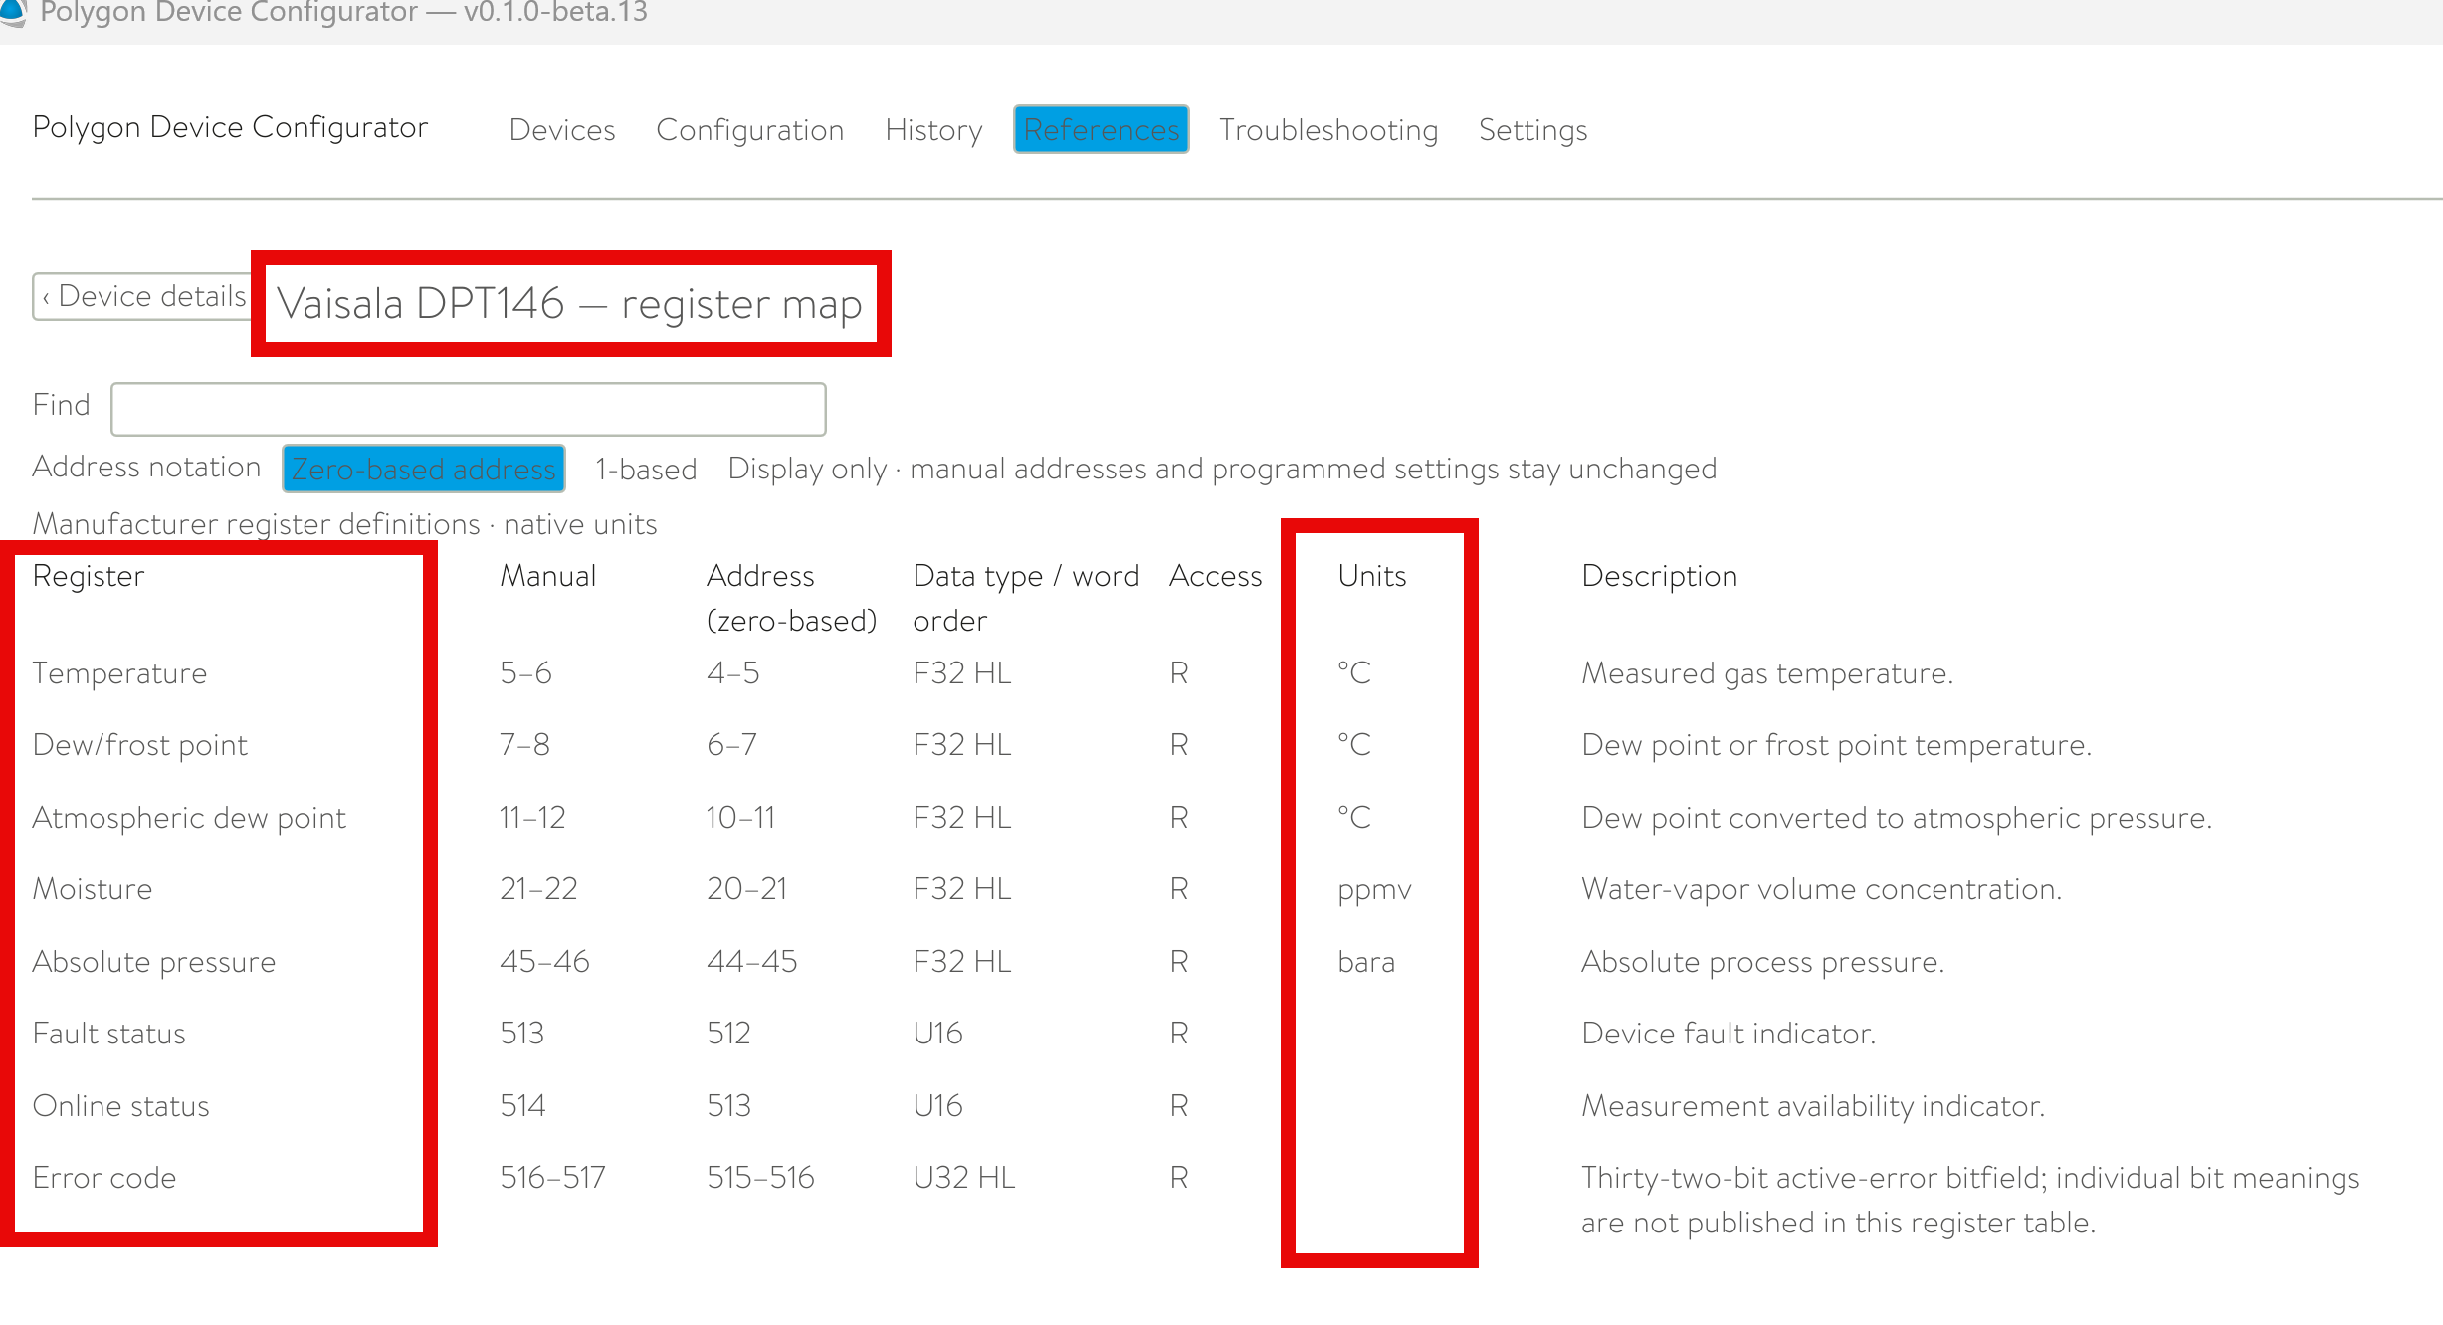
The register map shows the ordered bridge entries, source registers, and engineering units.
Important: Removing or reordering point-table entries changes the DSP mapping. Always confirm the installed bridge table before applying the standard profiles below.

7.4 Standard single-device DSP profiles
Use the following tables only when one instrument is configured on the bridge with its complete standard profile. Each profile starts at bridge entry 1; these are alternative configurations, not sections to combine on a single bridge.
1. Confirm the installed bridge table matches the complete profile, including entry order.
2. Edit each numbered Int measurement and enter the suggested name, output type, and unit.
3. Use a custom unit when the required unit is not available. Leave status/raw-code fields without an engineering unit unless explicitly specified.
4. Do not add a second scale factor to these standard values; their bridge multiplier is 1. Selecting a unit label does not convert the incoming value.
5. Leave unused entries and Cum fields unconfigured for these standard Int profiles. A cumulative quantity such as WattNode energy total still uses its assigned Int entry here.
Names may omit the device prefix when the DSP device name already identifies the instrument. The tables keep descriptive names so exported measurements remain self-explanatory.

7.4.1 Vaisala DPT146
8 bridge entries; use Int entries 1–8.
Bridge entry (Int) | Suggested DSP name | Output type | Unit / custom unit
1 | Temperature | Numeric | °C
2 | Dew/frost point | Numeric | °C
3 | Atmospheric dew point | Numeric | °C
4 | Moisture | Numeric | ppmv
5 | Absolute pressure | Numeric | bar absolute
6 | Fault status | Lookup table | None
7 | Online status | Lookup table | None
8 | Error code | Lookup table | None

DPT146 lookup entries:
Bridge entry | Incoming value | DSP label
6 — Fault status | 0 | One or more errors active
6 — Fault status | 1 | No errors
7 — Online status | 0 | Online data unavailable
7 — Online status | 1 | Online data available

Entry 8 note. Retain the numeric error code. A value of 0 means no errors; a nonzero value requires interpretation against DPT146 documentation. Do not map every nonzero value to a specific fault without a documented definition.

7.4.2 Vaisala HMD65 — non-metric
8 bridge entries; use Int entries 1–8.
Bridge entry (Int) | Suggested DSP name | Output type | Unit / custom unit
1 | Relative humidity | Numeric | %RH
2 | Temperature | Numeric | °F
3 | Dew point | Numeric | °F
4 | Dew/frost point | Numeric | °F
5 | Absolute humidity | Numeric | gr/ft³
6 | Mixing ratio | Numeric | gr/lb
7 | Wet-bulb temperature | Numeric | °F
8 | Device status | Lookup table | None

Unit note. “gr” means grains, not grams. Do not substitute g/m³ or g/kg for gr/ft³ or gr/lb without an actual conversion.
Status note. Entry 8 is a bit mask. Keep the raw value numeric unless DSP is deliberately configured to decode combinations of flags. The values below identify individual flags, not an exhaustive exact-value lookup.
Flag value (decimal) | Meaning
0 | Status OK — no flags set
1 | Critical error; maintenance needed
2 | Error; device may recover
4 | Warning
8 | Notification
16 | Calibration mode active

Example: value 6 combines flag 2 and flag 4, meaning error plus warning. An exact-value lookup containing only 1, 2, 4, 8, and 16 would not explain 6.
This profile does not include enthalpy at 143–144, error code at 514–515, humidity status at 518, or temperature status at 519. Register 142 is the second word of wet-bulb temperature at 141–142 and is included in bridge entry 7.
Reference: Vaisala HMD65 measurement data registers

7.4.3 ATI F12 — peracetic acid sensor
13 bridge entries; use Int entries 1–13.
The concentration fields below use ppm only when the installed peracetic-acid sensor is configured to report ppm. Confirm the unit and full-scale range on the transmitter. If it uses another unit, use that unit for entries 5, 8, and 13. Entry 8 is the primary displayed gas concentration; keep blanked and unblanked values clearly distinguished.
Bridge entry (Int) | Suggested DSP name | Output type | Unit / custom unit
1 | Expanded fault flags | Lookup table | None
2 | Expanded status flags | Lookup table | None
3 | Fault flags | Lookup table | None
4 | Status flags | Lookup table | None
5 | Unblanked concentration | Numeric | ppm — verify sensor unit
6 | Unblanked concentration percent full scale | Numeric | %
7 | Temperature | Numeric | °C
8 | Blanked concentration | Numeric | ppm — verify sensor unit
9 | Blanked concentration percent full scale | Numeric | %
10 | Loop output | Numeric | mA
11 | DAC output | Numeric | count
12 | Scaled concentration — raw count | Numeric | count
13 | Concentration full-scale range | Numeric | ppm — verify sensor unit

The instrument register numbers omit the holding-register 40000 prefix: register 33 is also written as 40033 in the interface manual. These are not DSP entry numbers.
Entries 1–4 are flag masks. Numeric output preserves every reported value. Use an exact-value lookup only when the required combinations have been defined; individual flag values are not a complete list of possible states.
Bridge entry | Meaning of zero | Interpretation of nonzero values
1 — Expanded fault flags | No expanded fault flags set | Decode the expanded fault mask
2 — Expanded status flags | No expanded status flags set | Decode status flags; these are not all faults
3 — Fault flags | No fault flags set | Decode the fault mask
4 — Status flags | No status flags set | Decode status flags, including alarm and inhibit states

For entry 12, preserve the raw count. Documented reference values are 0 = fault, 300 = inhibit, 800 = 0% of full scale, and 4000 = 100% of full scale. Values between 800 and 4000 represent intermediate concentrations, so those four labels alone are not a complete lookup table. Use entry 8 for the main gas-concentration measurement.
The complete profile has 13 entries. A shortened 10-entry table will not necessarily retain the same numbering. Match the actual exported bridge table before applying these labels.
Reference: Badger Meter F12/D product documentation

7.4.4 WattNode WND-M1-MB
12 bridge entries; use Int entries 1–12.
Bridge entry (Int) | Suggested DSP name | Output type | Unit / custom unit
1 | Energy total | Numeric | kWh
2 | Active power total | Numeric | W
3 | Active power 1 | Numeric | W
4 | Active power 2 | Numeric | W
5 | Active power 3 | Numeric | W
6 | Voltage AN | Numeric | V
7 | Voltage BN | Numeric | V
8 | Voltage CN | Numeric | V
9 | Frequency | Numeric | Hz
10 | Current 1 | Numeric | A
11 | Current 2 | Numeric | A
12 | Current 3 | Numeric | A

Voltage AN, BN, and CN are phase-to-neutral values. Do not label them as phase-to-phase voltage.
This standard profile contains numeric energy, power, voltage, frequency, and current values. It does not include current-transformer direction register 1607, so no direction lookup is needed for this configuration.
If register 1607 is used in another point table, direction mask 1 (0b001) reverses current transformer 1, mask 2 (0b010) reverses current transformer 2, and mask 4 (0b100) reverses current transformer 3. Multiple flags add together. This indicates configured polarity reversal, not automatic detection of a physically reversed transformer.
Reference: WattNode Module Modbus reference manual

8. Final verification
1. Compare each configured DSP measurement with a fresh Modbus Bridge reading for the same numbered bridge entry.
2. Confirm the label, unit, and any status interpretation are correct. A missing or failed read is not a zero measurement.
3. Power-cycle the bridge and connected devices, wait for them to report in DSP, and confirm the resulting data is logical.
4. If the bridge point table is changed later, review the DSP labels and mapping again.
Profile version note. The standard DSP mappings above correspond to the complete Polygon Device Configurator profiles documented as of 29 September 2026. Source profile files named in the DSP mapping notes: vaisala-dpt146-validated.tsv, hmd65-nonmetric-documentation-test.tsv, ati-badger-f12-d12-documentation-test.tsv, and wattnode-wnd-m1-mb-documentation-test.tsv.

9. Micronics U1000MKII Modbus and DSP entries
Use Int entries 1–15 only when the bridge table matches micronics-u1000mkii-hm-documentation-test.tsv in full. This is a documentation-based reference table, not a selectable application preset or a record of hardware verification. Each floating-point value uses two instrument registers but one bridge entry.
Units below are metric / imperial, selected by instrument register 40023. Heat-only entries apply to heat-meter models; omit them for a flow-only installation and remap DSP entry numbers to the resulting bridge table.
Int entry | Instrument registers | Suggested DSP name | Output | Unit or custom unit
1 | 40001 | Device identifier | Numeric | None
2 | 40002 | Device status | Numeric | None
3 | 40003 | System type (heat only) | Lookup | None
4 | 40007–40008 | Measured velocity | Numeric | m/s in either mode
5 | 40009–40010 | Measured flow | Numeric | m³/h / US gal/min
6 | 40011–40012 | Calculated power (heat only) | Numeric | kW / BTU/s
7 | 40013–40014 | Calculated energy (heat only) | Numeric | kWh / BTU*
8 | 40015–40016 | Hot temperature (heat only) | Numeric | °C / °F
9 | 40017–40018 | Cold temperature (heat only) | Numeric | °C / °F
10 | 40019–40020 | Temperature difference (heat only) | Numeric | °C difference / °F difference
11 | 40021–40022 | Volume total | Numeric | m³ / US gal
12 | 40023 | Instrument units | Lookup | None
13 | 40024 | Instrument gain | Numeric | dB
14 | 40025 | Signal to noise ratio | Numeric | dB
15 | 40026 | Signal strength | Numeric | %
Lookup values: entry 3: 4 = Heating, 12 = Chiller. Entry 12: 0 = Metric, 1 = Imperial. Device identifier 172 (0xAC) identifies the U1000MKII family. For entry 2, 0 means OK and any nonzero value means fault; retain the numeric code unless DSP supports a nonzero rule.
*Confirm imperial energy units against the exact model and manual revision: the wall-mount manual Issue 1.1 lists BTU, while the older flow-meter manual Issue 2.2 lists kBTU. Do not assume a unit label performs a conversion. Temperature difference conversions use a scale factor only, with no 32-degree offset.
Register sources: Micronics U1000MKII User Manual Issue 3.1, section 4.3; U1000MKII WM User Manual Issue 1.1, pages 29–30. Manufacturer register map

